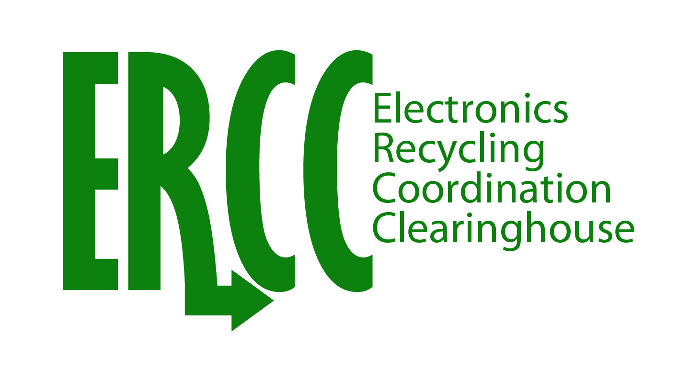
ERCC Workshop: Harmonizing State Programs
September 28, 2010
State Program Elements: Product Scope and Covered Entities
Issue Overview
Product scope refers to the electronic products that are covered by the state electronics recycling law. The scope of products covered by laws in the U.S. is much more limited than regulated programs in other parts of the world. In some cases, there are two separate lists of “covered” devices, those whose manufacturers need to register and fulfill a recycling obligation, and “eligible” devices that can be turned in by covered entities. Covered entities refers to the individuals or organizations that are eligible to utilize the recycling system that is provided for under the law. As state laws have been passed over time, different sets of products and covered entities have been incorporated. In addition to large distinctions of different product categories, such as desktop computers, being covered in one state but not another, there are several smaller inconsistencies such as screen size limitations (4”, 7”, 9”) and how “small” a small business must be to be eligible (10 employees, 50 employees). This causes confusion for manufacturers needing to register and comply in multiple states, for consumers expecting all “electronics” to be covered and accepted, and for collectors and recyclers who may need to separately fund, manage and account for covered and non-covered products from various entities. See the second page for tables detailing the differences among the states.
Products Impacted
All - desktop computers, laptop computers, computer monitors, printers, televisions, video game consoles (and in NY only: small scale servers, electronic keyboards, electronic mice, fax machines, scanners, VCRs, DVRs, portable digital music players, DVD players, digital converter boxes, cable/satellite receivers)
States Impacted -All
Challenges
- This has been one of the more controversial topics when state legislation is discussed. Changing product scope or covered entities in order to harmonize will also likely be controversial
- Product categories are constantly changing with new technology – difficult to keep relevant
- Different covered entities may be more prevalent in certain states
- Adding more covered products requires additional tracking of manufacturers; adding covered entities requires more collector education and training.
Possible Solutions
- Define rationale and method for including and excluding product categories and covered entities
- Use products and entities from methodology to harmonize on a consistent set across the states

Product Scope By State

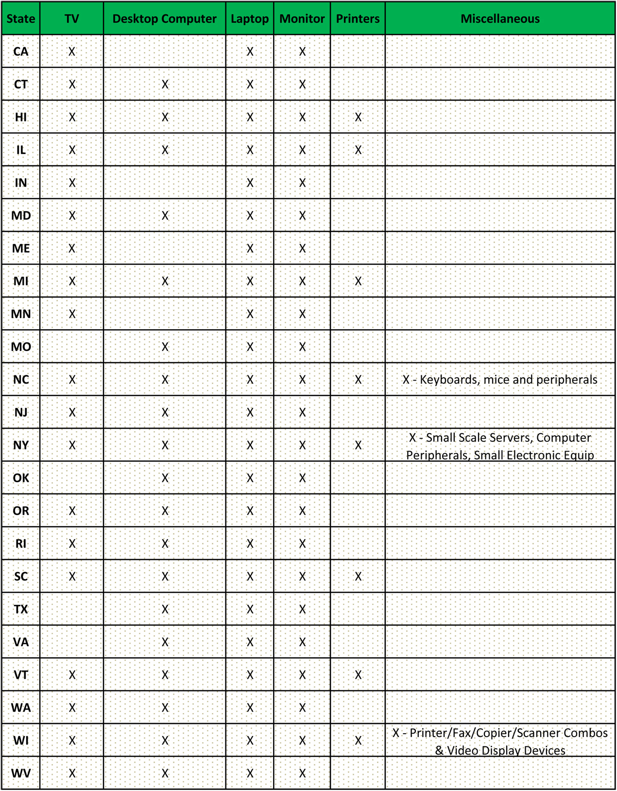

Covered Entities By State
State | Households | Businesses | Government | Non-profit/ Charity | Schools | Notes
CA | X | X | X | X
CT | X
HI | X | X | X | X | X
IL | X
IN | X | X* |  |  | X | *Small businesses
MD | X | X | X | X
ME | X
MI | X | X* |  |  |  | *Fewer than 7 employees
MN | X
MO | X* |  |  |  |  | *Who use a computer for home or business use
NC | X |  |  | X* |  | *Fewer than 10 employees
NJ | X | X* |  |  |  | *Fewer than 50 employees
NY | X | X | X | X
OK | X* |  |  |  |  | *Who use a computer for home or business use
OR | X | X* |  | X |  | Or any entity with fewer than 7 devices. *Small businesses
RI | X |  |  |  | X
SC | X
TX | X* |  |  |  |  | *Who use a computer for home or business use
VA | X* |  |  |  |  | *Who use a computer for home or business use
VT | X | X* |  | X | X | *Fewer than 10 employees
WA | X | X | X | X | X | *Small gov't and small businesses
WI | X |  |  |  | X
WV | X | X | X | X | X

